Figure 1 – PIF and CEO Endorsement stage
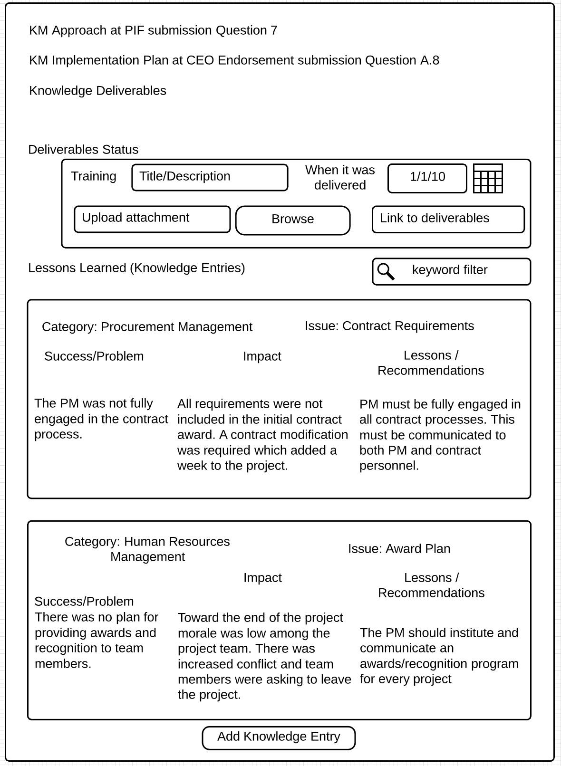
Figure 2 – Implementation stage
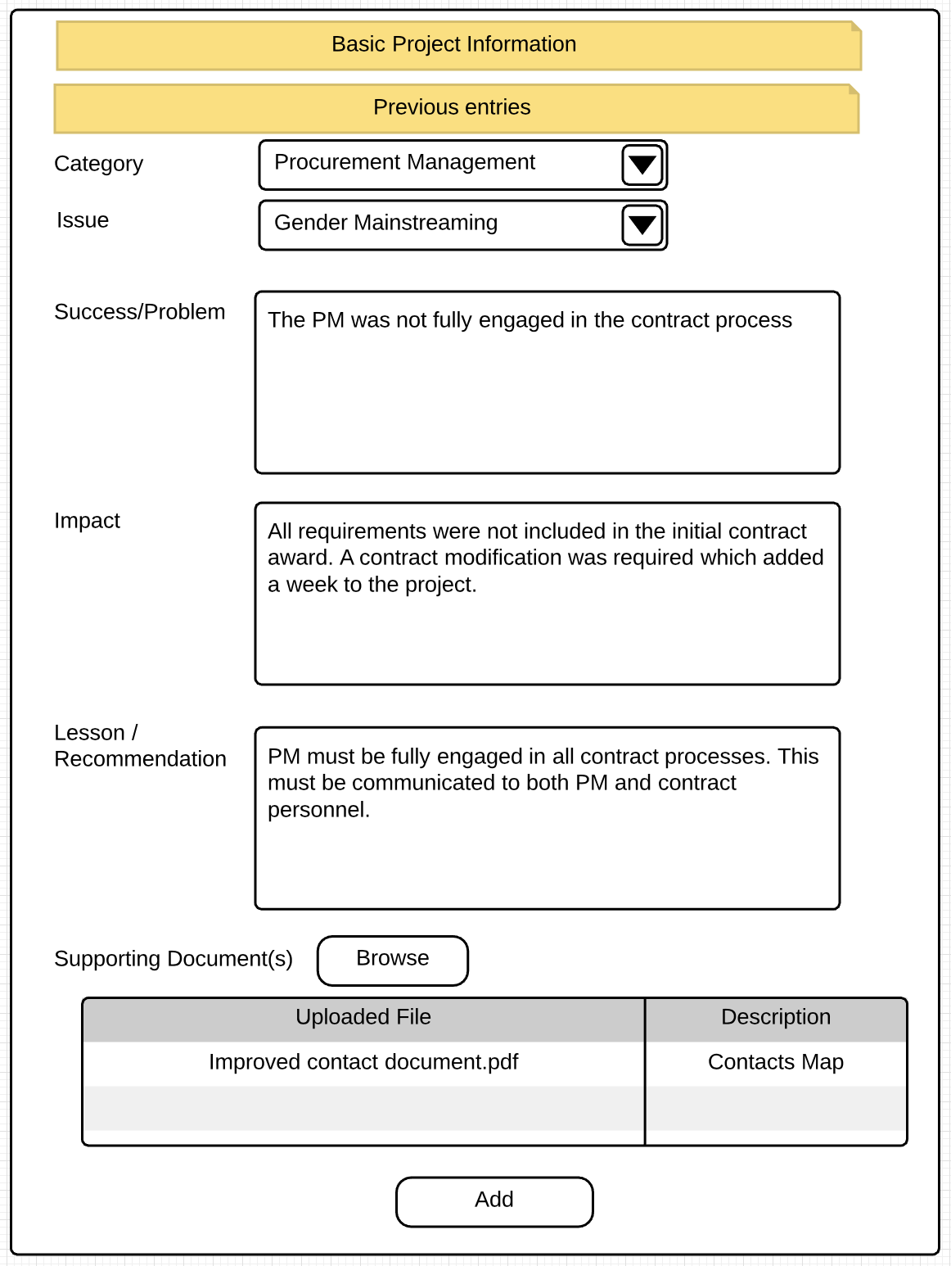
Available categories are: Procurement Management, Human Resources Management, Scope Management, Quality Management, Stakeholder Engagement, Delivery of Global Environmental Benefit, Other.
Available issues are: Gender Minstreaming, Public/CSO involvement, Replication/Scaleup, Cofinancing Private Sector Engagement, Knowledge/Learning, Scientific research Indigenous Peoples, Integrated Approaches, Innovation/Demonstration (technology or practice), Other.
Each text box is limited to 250 characters. Show this instruction on the form and the current character count.

