Learning Stations:
When we arrive at the project site there will be a briefing by PEMSEA and SGP project staff. After the briefing we will divide into groups to visit 5 “Learning Stations”. Group 1 will begin with Learning Station 1, Group 2 will begin with Learning Station 2 and so on. After 20 minutes, each group will then proceed to the next learning station. (The learning station descriptions and a color coded map are included on page 2)
The learning stations allow both participants and project staff/stakeholders to:
- Display and discuss a project, highlighting lessons and good practices emerging from their own work and experiences with respect to key project components;
- Discuss multiple perspectives and ideas on a project component or topic;
- Interact directly, face-to-face, with project managers, beneficiaries, co-financiers, and other relevant stakeholders;
- Identify and demonstrate good practice approaches.

Knowledge Passports:
Each participant will receive a GEF Knowledge Passport. This is a tool that helps participants see how projects are providing lessons and results. At each Learning station, we ask that participants make notes in their Passports about the lessons learned and results that we were discussed. When participants complete each Learning Station, they will receive a sticker in their passport. At the end of the day, we will collect the passports and have a raffle, so make sure you complete the passport!

Knowledge Day Timetable:
Time | Activity | Groups
8:15 – 9:00 | Depart from hotel, please have breakfast prior to departure and arrive at the lobby at 8:00 - 15 min prior to departure. | All
9:00 – 9:30 | Arrival and briefing from PEMSEA and SGP | All
9:30 – 11:30  Each Group rotates in sequence and spends 20 Mins at each Learning Station | Learning Station 1 : SGP Sustainable Harvesting of Cu Lao Cham Land Crab | Group 1
 | Learning Station 2 : SGP Biodiversity conservation - Nya Palm conservation and ecotourism | Group 2
 | Learning Station 3 : SGP Waste management and women’s empowerment | Group 3
 | Learning Station 4 : PEMSEA Coastal tourism and livelihood development | Group 4
 | Learning Station 5 : PEMSEA Engaging fisher communities in sustainable coastal resource management | Group 5
11:30 - 12:00 | Wrap up session - Feedback and Discussion, exit survey, raffle and prizes! (please note, you must complete your GEF Knowledge Passport and exit survey to be eligible for the raffle!) | All
12:00 -13:30 | Lunch & Cultural Entertainment | All
13:30 | Depart for Hotel | All

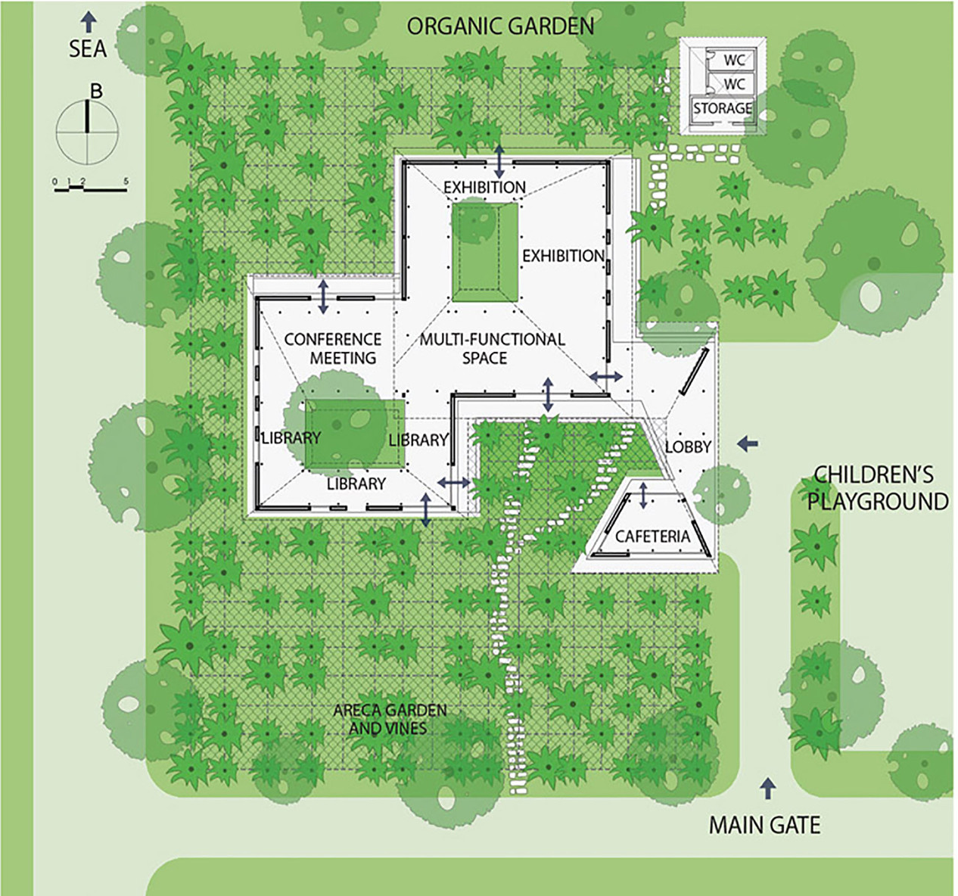
Learning Station Map
Learning Station 1 : Sustainable Harvesting of Cu Lao Cham Land Crab
Learning Station 2 : Biodiversity conservation - Nya Palm conservation and ecotourism
Learning Station 3 : Waste management and women empowerment
Learning Station 4 : Coastal tourism and livelihood development
Learning Station 5 : Engaging fisher communities in sustainable coastal resource management

1
5
4
3
2

