GEF Knowledge Day Passport

Learning Station 1 – Land Restoration
Project staff and /or stakeholders talked about which issue?

What was the main lesson(s) learned?
What were the results (If Any)?

Provide an example of how this knowledge can be applicable/replicable in your country/project.

Learning Station 2 - SLM
Project staff and /or stakeholders talked about which issue?

What was the main lesson(s) learned?
What were the results (If Any)?

Provide an example of how this knowledge can be applicable/replicable in your country/project.

Learning Station 3 – Climate Smart Agriculture
Project staff and /or stakeholders talked about which issue?

What was the main lesson(s) learned?
What were the results (If Any)?

Provide an example of how this knowledge can be applicable/replicable in your country/project.

Learning Station 4 – Food Security IAP
Project staff and /or stakeholders talked about which issue?

What was the main lesson(s) learned?
What were the results (If Any)?

Provide an example of how this knowledge can be applicable/replicable in your country/project.

LEARNING STATIONS
  - Learning stations are a highly flexible method of experiential learning. They engage participants by sight, sound, touch smell, (and even taste)! They may include listening to expert presentations; examining goods produced by the project; looking through documentation (books, photos, maps, posters, etc.); watching audio/video presentations and photography exhibits; engaging in role-playing exercises.
  - Participants are encouraged to interact by asking questions; taking photos and videos; and providing feedback to the project stakeholders.

You will be able to:
- Discuss the project components, highlighting lessons, good practice approaches and experiences and results ;
- Interact directly with stakeholders and partners to see multiple perspectives and ideas on a project component or topic;
- Support collective learning and build networks;
- Discuss key topics from the previous days at the ECW such as: Partnerships, Synergies/Coordination, Global Environmental Goals, Stake Holder Engagement, Gender, Green Finance, Knowledge and Learning, CCCD, and Results (How do you track progress).

GEF KNOWLEDGE
PASSPORT

Name:

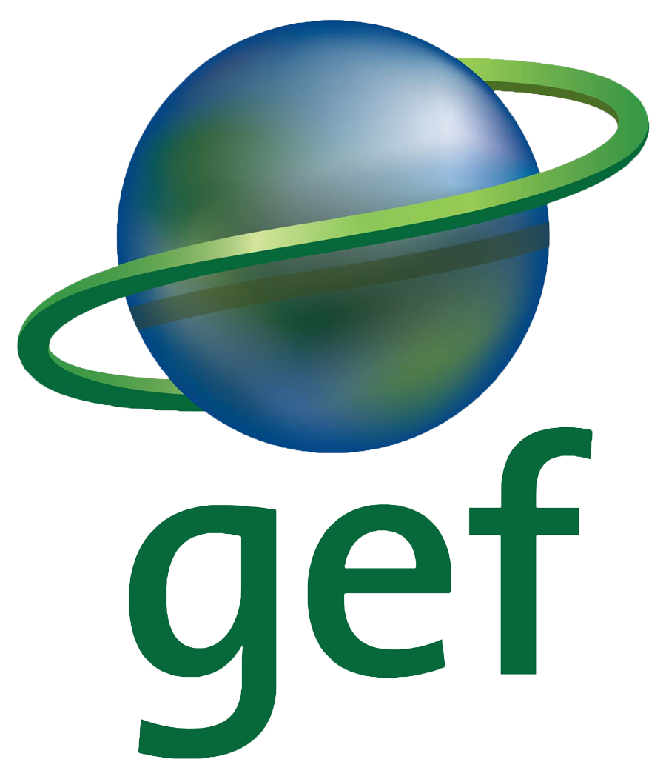
Country:

