Memorandum

To : TEEMP BRT Users

From: Jacob Mason, Transport Research and Evaluation Manager, ITDP

Date: April 13, 2015

Re: TEEMP Revisions
Research staff at ITDP have recently become aware of a number of opportunities to improve the Transport Emissions Evaluation Model for Projects (TEEMP) BRT Evaluation Tool. This memorandum summarizes the existing shortcomings and discusses a set of proposed changes.
Fuel Efficiency Estimates
The existing tool uses data to revise vehicle fuel efficiency based on estimated vehicle speeds in various scenarios. The original data showed an almost exponential growth in emissions as speed decreased. We now believe that better data is available, leading to more accurate results. ITDP has examined the data from the "Assessment and reliability of transport emission models and inventory systems" (ARTEMIS) project, which combines experience from different emission models and research to harmonize emission estimates at the national and international level. The project is conducted by IFSTTAR (the French Institute for Sciences and Technologies of Transport, Planning and Networks). The data is based on research coordinated by the European Environment Agency (EEA) and packaged as the COPERT 4 software tool, used world-wide to calculate air pollutant and greenhouse gas emissions from transport. The following charts compare the factors for the impact of speed used in the current TEEMP model to those derived from the ARTEMIS research. We propose to use an average of the ARTEMIS factors for each mode in a revised TEEMP model.

Midi, Standard and Articulated Buses x TEEMP Bus

Passenger Van (Diesel >2.0L Eng.) x Mini-Bus in TEEMP

Passenger Car (Gasoline <=2.0L Eng.) x Car in TEEMP

Motorcycle (2 and 4 stroke Eng.) x Motorcycle in TEEMP

The TEEMP model currently includes speed impacts for light-duty and heavy-duty trucks. Since BRT almost never replaces these types of trips, they have not been updated from the existing numbers. Also, the ARTEMIS project does not include 3 wheeler data, so these numbers have not been updated either.
New Trips Generated by BRT
The tool currently calculated the emissions reduction as the total emissions from trips that switched to BRT minus the emissions for the BRT trips. However, the way this is currently calculated, it excludes the emissions from BRT trips that were not made at all before the BRT was implemented, artificially increasing the emissions reduction from the BRT. To improve the results, we proposed to include the new BRT trips that were not made before the BRT was implemented.
Changes to Average Emissions Factors
To improve the results for the Shortcut methodology, the summary of analyses of existing projects has been updated to include the latest analyses. GHG results for Guangzhou BRT, TransOeste BRT in Rio de Janeiro, and TransCarioca BRT also in Rio, calculated by ITDP, were added to the list of results along with updated links to data sources. The analyses for these systems was performed using the GEF-approved TEEMP methodology, based on surveys conducted after the projects were completed.
A methodology was also developed to remove outliers from the averages. The sample average and standard deviation was calculated for all data for emissions reductions per km and emissions reductions per daily passenger. Then the average plus one standard deviation was plotted on a graph for both emissions reductions per km and emissions reductions per daily passenger, and a line was drawn between the two points. All data points above the line were considered to be outliers. A second average was take from the remaining data points (not including outliers), and this was used for the TEEMP shortcut analysis.
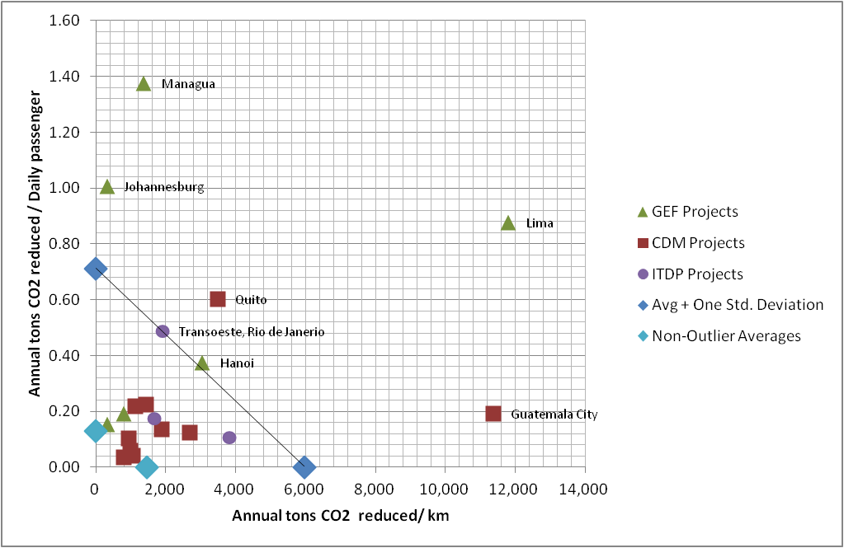
The outliers removed include the Lima, Hanoi, Johannesburg, and Managua GEF analyses; the Guatemala City and Quito CDM analyses; and the TransOeste ITDP analysis.
The average GHG reductions have changed as follows:
Average Annual GHG Reductions (CO₂eq)
Tons per km Tons per Daily Passenger
Existing 2,236.20 0.41
Proposed 1,468.54 0.13

Other Modifications
To improve the readability of the report, several modifications have been made to the layout and results and headings. Most importantly, the Summary results page has been modified to calculate average yearly emissions reductions.

